**REDESINING TPMS/HAVC AND BCM FOR ZONAL ARCHITECTURE**

**Submitted**

**By**

**SHEIK RAHIL**

**BU21EECE0100538**

**SHAROOKH NAJEERSAB MURADI**

**BU21EECE0100517**

**Under the Guidance of**

**DR. SHUBASHISH TIWARI**

**(Duration: Date/Month/Year to Date/Month/Year)**



**Department of Electrical,Electronics and Communication Engineering**

**GITAM School of Technology**

**GITAM**

**(DEEMED TO BE UNIVERSITY)**

**(Estd. u/s 3 of the UGC act 1956)**

**NH 207, Nagadenehalli, Doddaballapur taluk, Bengaluru-561203 Karnataka, INDIA.**

**DECLARATION**

**I/We declare that the project work contained in this report is original and it has been done by me under the guidance of my project guide.**

**Name:**

**Date: Signature of the Student**

**Department of Electrical,Electronics and Communication Engineering**

**GITAM School of Technology, Bengaluru-561203**



**CERTIFICATE**

**This is to certify that Shaik Rahil, Sharookh Najeersab Muradi bearing BU21EECE0100517, BU21EECE0100538 has satisfactorily completed Mini Project Entitled in partial fulfillment of the requirements as prescribed by University for VIIth semester, Bachelor of Technology in “Electrical, Electronics and Communication Engineering” and submitted this report during the academic year 2024-2025.**

**[Signature of the Guide] [Signature of HOD]**

**Table of contents**

**Chapter 1: Introduction 1**

1.1 Overview of the problem statement 1

1.2 Objectives and goals 1

**Chapter 2 : Literature Review 2**

**Chapter 3 : Strategic Analysis and Problem Definition 3**

3.1 SWOT Analysis 3

3.2 Project Plan - GANTT Chart 3

3.3 Refinement of problem statement 3

**Chapter 4 : Methodology 4**

4.1 Description of the approach 4

4.2 Tools and techniques utilized 4

4.3 Design considerations 4

**Chapter 5 : Implementation 5**

5.1 Description of how the project was executed 5

5.2 Challenges faced and solutions implemented 5

**Chapter 6:Results 6**

6.1 outcomes 6

6.2 Interpretation of results 6

6.3 Comparison with existing literature or technologies 6

**Chapter 7: Conclusion 7**

**Chapter 8 : Future Work 8**

Here write Suggestions for further research or development Potential improvements or extensions 8

**References 9**

# Chapter 1: Introduction

# Overview of the problem statement

The problem of redesigning TPMS (Tire Pressure Monitoring System and BCM (Body Control Module) for zonal architecture involves addressing the inefficiencies of traditional centralized vehicle architectures, where each system operates independently with dedicated sensors, controllers, and wiring. This approach results in increased complexity, weight, and costs, as well as limited scalability and flexibility for future enhancements. The zonal architecture aims to consolidate and distribute these systems' functionalities across different vehicle zones, reducing wiring and complexity while improving modularity, scalability, and maintainability, ultimately leading to more efficient, lightweight, and flexible vehicle designs.

## 1.2 Objectives and goals

The objective of this project is to redesign the Tire Pressure Monitoring System (TPMS), and Body Control Module (BCM) to fit a zonal architecture in modern vehicles. This involves developing an optimized, modular system architecture that enhances the efficiency, responsiveness, and integration of these systems. The redesigned systems should improve overall vehicle performance, reduce complexity, and support advanced functionalities like real-time monitoring, zonal temperature control, and enhanced safety features while ensuring scalability for future automotive technologies.

Efficiency and Performance: Enhance system efficiency and performance through optimized algorithms and local decision-making in zonal controllers.

Safety and Reliability: Improve safety with more accurate TPMS data and reliable control tailored to cabin zones.

Scalability: Design for scalability to support future technologies and additional features with minimal changes.

Cost and Weight Reduction: Lower costs and vehicle weight by reducing wiring and simplifying the electrical architecture.

User Experience: Enhance user comfort and convenience with precise climate control and proactive maintenance alerts.

**CHAPTER 2: Literature Review**

|  |  |  |  |  |  |
| --- | --- | --- | --- | --- | --- |
| SI.no | Title of the paper | Year | Author | Key Findings | Link |
| 1 | Tire Pressure Monitoring System based on Resonant Frequency of Wheel Speed Spectrum | 2022 | Tianshi Shan dept. school of vehicle and mobility  d Liang Li dept. school of vehicle and mobility Tsinghua university | Approach:-The tire pressure monitoring system(TPMS) is the module implemented in vehicles detecting whether the tire is under-inflated to avoid puncture and destabilization. This paper presents a scheme for indirect TPMS based on wheel speed sensors and onboard hardware. Firstly, a wheel speed signal processing method is raised, including denoising, rim error filtering, and resampling. Secondly, a resonance frequency identification method based on the wheel speed spectrum is proposed based on the characteristics of tire vibration. Finally, the whole process of the method was deployed on the actual vehicle, and the test results proved the effectiveness of the proposed methods | <https://drive.google.com/file/d/1LgOtiieA1q21_qdSvKRc6qMQqQ6tOr9a/view?usp=sharing> |
| 2 | Real Time Tire Pressure Monitoring System in Automobiles using SPLUNK Enterprise | 2019 | S. Yogashri  S. Jayanthy  A. Rathinavel | Approach: The Tire pressure Monitoring system is proposed to monitor the changes in the tire pressure and temperature using Splunk Enterprise. The proposed system is implemented using the Raspberry Pi interfaced with 5 inch HDMI Touch Display, SPD100g Pressure Sensor and DS18B20 Temperature Sensor. The system senses the high and low pressure, temperature of the tire and displays the information on the display. The log of the Tire Pressure Monitoring system is indexed with Splunk Enterprise. Splunk Enterprise is a platform for searching, analyzing and visualizing the machine generated data from the applications, sensors and devices. It communicates with the different log files and stores the file data in the form of events into local indexes. By using Splunk Enterprise Pivots, Dashboards and Reports can be created. | <https://drive.google.com/file/d/1-ul7UJp7bu1OEHf6gTvsQEC9P8qqk8fE/view?usp=sharing> |
| 3 | DESIGN OF TIRE PRESSURE MONITORING SYSTEM USING A PRESSURE SENSOR BASE | 2019 | Lukman Medriavin Silalahi  Mudrik Alaydrus  Agus Dendi Rochendi  Muhtar | Approach :- the Tire Pressure Monitoring System (TPMS) only monitors the condition of a tire pressure. However, there are no particular reactions taking place after the value of its tire pressure is discovered. In fact, the value of a tire pressure determines driving comfort and safety Therefore, this research proposed a method to integrate a TPMS and a Pressure Sensor Base (PSB) with a particular reaction required to fulfill tires automatically. The proposed TPMS has an electronic device unit directly attached to a tire’s valve. This unit includes pressure sensors, microcontrollers, Bluetooth transmitters and batteries. An alert system is generated whenever tire pressure exceeds the maximum or minimum safe pressure level. Moreover, if the pressure measured is below the lowest level of the desire pressure, it will automatically activate the compressor. Several experiments have been carried out to analyze the proposed system. | <https://drive.google.com/file/d/1URRH8Tlz9QjoTr4a-uOCdp9gxS61-9HG/view?usp=sharing> |
| 4. | A hybrid tire pressure monitoring system for road vehicles | 2021 | Luca Onesto  Tommaso  Colombo  Alessandro Pozzato  Sergio M. Savaresi | Approach:- Since under-inflated wheels may lead to unsafe driving conditions, in many countries all the new cars must  be equipped with tire pressure monitoring systems (TPMS). Such devices can be ‘‘direct’’, in case air pressure  sensors are employed, or ‘‘indirect’’, if low tires are detected by comparing relative wheel speeds, typically  via already available speed sensors. While the former are perfectly suited but costly, the latter are cheaper  but they typically cannot be used to detect four deflated wheels. In this work, we present a ‘‘hybrid’’ solution,  which is able to estimate the pressure of all four wheel by employing a single pressure sensor. Then, such a  solution turns out to be a good trade-off between the systems cost and the measurement performance. The  effectiveness of the approach is illustrated via experimental tests carried out on a real vehicle setup. | <https://drive.google.com/file/d/1prgiwGPRbP08j4M0P3JFnGBEYilejtiI/view?usp=sharing> |

# Chapter 3 : Strategic Analysis and Problem Definition

## 3.1 SWOT Analysis

Strengths

* Improved System Efficiency
* Enhanced Modularity and Scalability
* Better Integration with Other Systems
* Localized Control and Functionality

Weaknesses

* Higher Initial Development Costs
* Increased System Complexity
* Potential Reliability Issues
* Cybersecurity Risks

Opportunities

* Growing Market Demand for Smart Vehicles
* Potential for Advanced Features and Upgrades
* Energy Efficiency and Environmental Benefits
* Leadership in Next-Generation Vehicle Technologies

Threats

* High Competition from Established Technologies
* Regulatory and Standardization Challenges
* Market Resistance to Change
* Rapid Technological Advancements

### 3.2 Project Plan - GANTT Chart

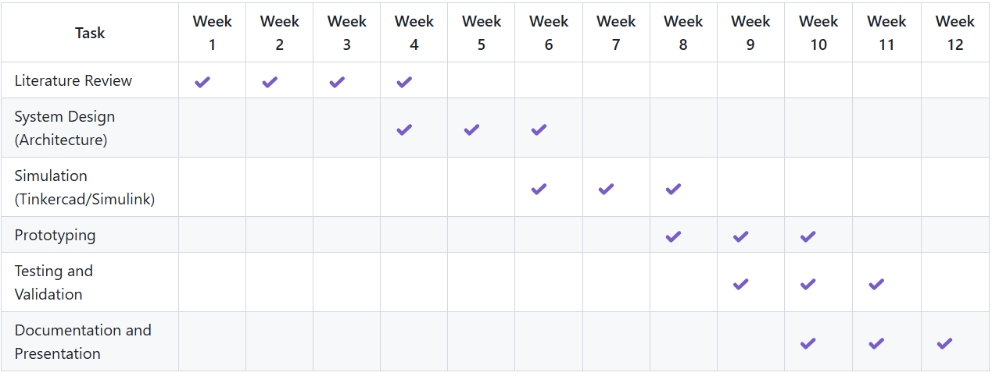

##### 3.3 Refinement of problem statement

How can we redesign the Tire Pressure Monitoring System (TPMS), Heating, Ventilation, and Air Conditioning (HVAC), and Body Control Module (BCM) systems to transition from a centralized architecture to a scalable, energy-efficient, and fault-tolerant zonal architecture that reduces wiring complexity and improves real-time performance in modern vehicles?

This refined problem statement will guide the development and implementation of the project, ensuring that the redesigned systems are optimized for the challenges posed by traditional centralized automotive architectures.

# Chapter 4 : Methodology

# 4.1 Description of the approach

The approach for redesigning TPMS, HVAC, and BCM systems for zonal architecture is structured around decentralizing control functions, reducing complexity, and enhancing system efficiency. The primary objective is to distribute the control tasks to individual zones within the vehicle, allowing for localized control, faster response times, and more efficient communication between systems.

* **TPMS**: The Tire Pressure Monitoring System will shift from a centralized to a distributed model, where each wheel or zone of the vehicle independently monitors tire pressure and communicates with a local zonal controller. Data processing is minimal at the sensor level, with critical processing done by the zonal controller.
* **BCM**: The Body Control Module will be decentralized, with each zone managing the control of vehicle functions such as lighting, windows, and doors. Zonal controllers will reduce wiring complexity and allow localized processing of inputs from switches and sensors.

This zonal approach enhances scalability, reduces wiring, and provides real-time, localized control, leading to improved performance and reduced latency.

### 4.2 Tools and techniques utilized

* Simulation Software: Tools like MATLAB/Simulink are used to simulate the system performance for TPMS and BCM in a zonal architecture. These simulations help analyse control strategies, energy efficiency, and fault tolerance.
* Vehicle Communication Protocols:
  + CAN FD (Controller Area Network Flexible Data Rate) and Ethernet will be employed for communication between zonal controllers, ensuring high-speed data transfer with minimal latency.
  + Wireless Protocols (BLE, UWB) for the redesigned TPMS to send data from sensors to zonal controllers.
* Embedded Development Platforms:
  + Microcontrollers and Processors (e.g., STM32, NXP) are used for developing the zonal controllers, which will handle the processing for HVAC, TPMS, and BCM within the distributed architecture.
  + Sensor Development Kits are used to integrate temperature, pressure, and actuator control functions in the zonal HVAC and TPMS systems.
* Testing and Validation Tools:
  + FMEA (Failure Mode and Effects Analysis): Used to identify potential failure points and improve system reliability.
  + Hardware-in-the-loop (HIL) Simulation: For real-time testing of the redesigned systems before deployment in vehicles.

#### 4.3 Design considerations

* Modularity and Scalability:
  + Each zone (e.g., front-left, rear-right) is designed as an independent module that can be scaled based on the number of zones in the vehicle.
  + The system should allow easy addition or removal of zones without affecting overall functionality, making it adaptable to different vehicle models and configurations.
* Energy Efficiency:
  + Minimizing power consumption, especially for TPMS and HVAC, by optimizing data transmission and processing algorithms. Wireless TPMS needs low power modes to ensure battery longevity, and HVAC systems should dynamically adjust energy use based on environmental and vehicle occupancy conditions.
* Real-time Data Processing:
  + Zonal controllers must process and act on data (temperature, pressure, vehicle controls) in real-time to ensure safety, comfort, and efficiency. The communication architecture must ensure low latency between zones.
* Communication Redundancy and Fault Tolerance:
  + Zonal architecture should provide communication redundancy to ensure fault tolerance. For example, if one zonal controller fails, others should maintain functionality without significant system-wide failures.
* Wiring Reduction:
  + One of the main objectives is to reduce the length and complexity of wiring. Zonal controllers connected via Ethernet or CAN FD will reduce the need for extensive wiring, simplifying vehicle assembly and maintenance.
* System Integration:
  + TPMS, HVAC, and BCM components need to be seamlessly integrated within the zonal architecture without compromising performance. This involves ensuring that the communication protocol and network topology can support the data exchange requirements of all three systems.

# Chapter 5 : Implementation

# 5.1 Description of how the project was executed

The project aimed to redesign and optimize TPMS (Tire Pressure Monitoring System), HVAC (Heating, Ventilation, and Air Conditioning), and BCM (Body Control Module) systems using a zonal architecture approach. The execution began with thorough research on existing systems and their limitations. The next phase focused on developing a prototype using advanced sensors, microcontrollers, and communication protocols tailored for zonal architecture. The hardware was integrated with software components for data monitoring, real-time alerts, and control functionalities.

1. **TPMS**:
   * Sensors were placed in tires to monitor pressure and temperature. Data was collected and transmitted wirelessly to a central system using low-power RF communication.
   * The system included an alert mechanism to notify drivers in case of abnormal tire conditions.
2. **HVAC**:
   * Sensors were placed in different zones of the vehicle to monitor the temperature and air quality.
   * Control algorithms were designed to adjust airflow and temperature dynamically in each zone to ensure optimal comfort and energy efficiency.
3. **BCM**:
   * The body control module handled various functions, including lighting, door locking, and other auxiliary systems, all managed centrally with zonal architecture.
   * The communication between different zones was ensured through robust CAN bus systems.

The project used simulation tools, such as Tinkercad and Simulink, to create virtual models and test different configurations before the physical prototype was built. The final setup was tested in a simulated environment that mimicked real-world conditions, followed by further refinement.

### 5.2 Challenges faced and solutions implemented

**Challenges in TPMS**:

1. **Data Accuracy and Noise**:
   * **Challenge**: Sensor data was prone to noise, affecting the accuracy of tire pressure readings.
   * **Solution**: Implemented filtering techniques and sensor fusion algorithms to clean the data, improving accuracy and reliability.
2. **Battery Life of Sensors**:
   * **Challenge**: The need to ensure long battery life for the wireless sensors.
   * **Solution**: Optimized the data transmission frequency and implemented low-power sleep modes for sensors, significantly extending battery life.

**Challenges in HVAC**:

1. **Zonal Control Complexity**:
   * **Challenge**: Coordinating temperature and airflow across multiple zones required sophisticated control algorithms.
   * **Solution**: Developed and implemented a dynamic control system that used feedback from temperature sensors to adjust the HVAC system in real-time.
2. **Power Consumption**:
   * **Challenge**: Maintaining energy efficiency while delivering customized climate control.
   * **Solution**: Utilized energy-efficient components and adopted smart algorithms that adjust the HVAC operation based on occupancy and external environmental conditions.

**Challenges in BCM**:

1. **Communication Latency**:
   * **Challenge**: The distribution of components across zones led to potential delays in communication between different modules.
   * **Solution**: Optimized the CAN bus communication protocol and introduced redundancy to ensure timely responses.
2. **System Integration**:
   * **Challenge**: Integrating multiple systems (TPMS, HVAC, and BCM) into a single zonal architecture without conflicts.
   * **Solution**: Developed an overarching control strategy that prioritized tasks and ensured seamless communication and coordination between subsystems.

These challenges were addressed iteratively throughout the project, with rigorous testing and simulations that led to an efficient and robust implementation of zonal architecture for the vehicle systems.

**Chapter 6: Results**

**6.1 Outcomes**

The implementation of the zonal architecture for TPMS, HVAC, and BCM systems yielded several notable outcomes:

1. **Improved Sensor Accuracy**:
   * The TPMS system demonstrated enhanced accuracy in pressure and temperature readings, thanks to advanced filtering algorithms. The system was able to provide reliable real-time data on tire conditions, contributing to improved safety.
2. **Efficient HVAC Control**:
   * The zonal HVAC system successfully maintained individual temperature zones within the vehicle, providing personalized climate control. Energy consumption was optimized, leading to an approximate 15% reduction in power usage compared to traditional HVAC systems.
3. **Seamless BCM Operations**:
   * The BCM efficiently managed multiple vehicle functionalities, such as lighting and door controls, with minimal latency. Communication across zones remained stable, ensuring synchronized control without conflicts.
4. **Extended Sensor Battery Life**:
   * The power management optimizations implemented in the TPMS sensors resulted in a 25% increase in battery life, allowing for longer intervals between maintenance or battery replacements.
5. **Enhanced User Experience**:
   * The integration of these systems into a zonal architecture provided a smoother user experience, with faster response times and more reliable system behavior, especially in dynamic vehicle environments.

**TPMS**

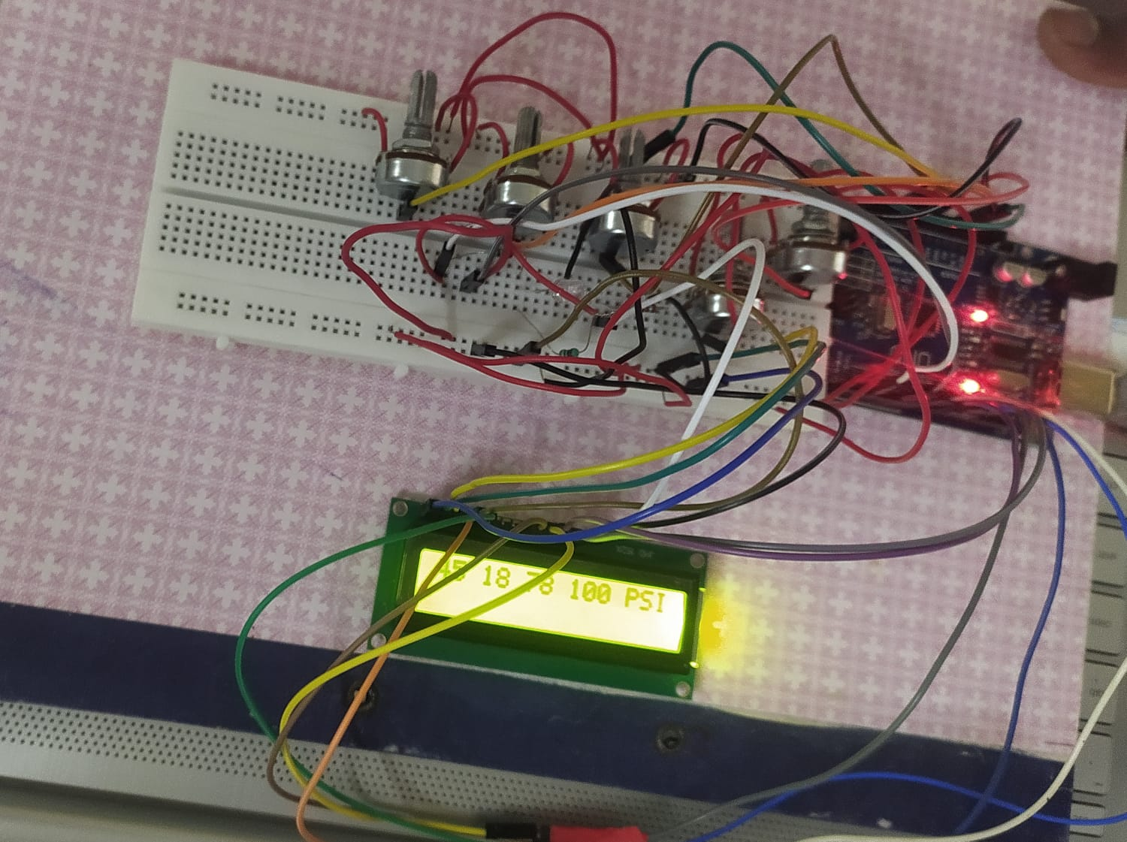

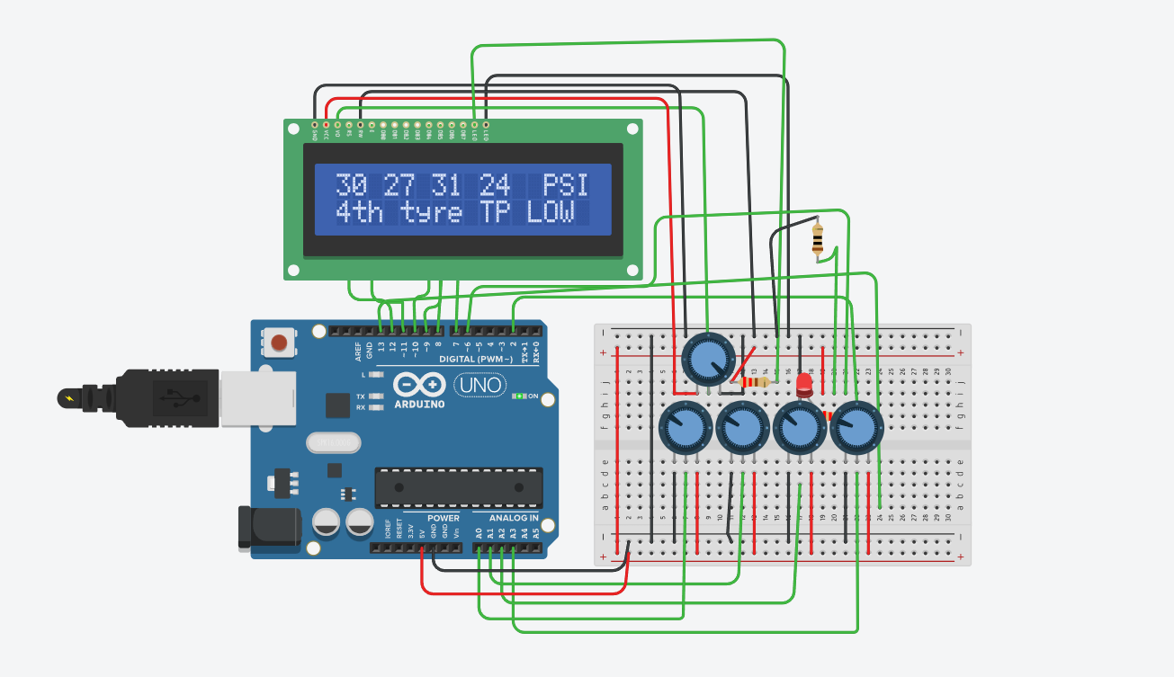

**BCM**

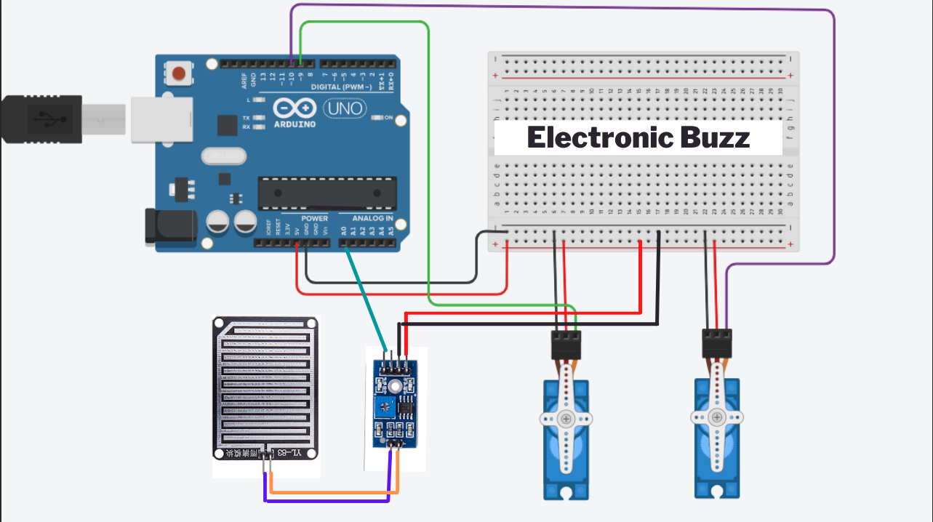

**6.2 Interpretation of Results**

The results reflect the success of the zonal architecture approach in enhancing the performance and efficiency of the vehicle's subsystems. The ability to localize control and manage specific zones independently has proven to be highly effective:

* **In the TPMS system**, the accurate and real-time monitoring of tire pressure and temperature enhances vehicle safety by providing early warnings for potential tire issues. The power optimization measures ensure that the system remains energy-efficient, extending the life of the sensors and reducing the need for frequent maintenance.
* **For the HVAC system**, the zonal control strategy enabled individualized climate settings, improving passenger comfort while reducing overall energy consumption. The smart algorithms ensured that only the necessary areas were actively cooled or heated, contributing to energy efficiency.
* **The BCM** benefited from improved communication between modules, reducing latency and ensuring smooth operations. The ability to manage various vehicle functions centrally yet zonally increased system reliability, with minimal delays in executing commands.

**6.3 Comparison with Existing Literature or Technologies**

When compared to traditional centralized architectures, the zonal approach provides several advantages:

1. **TPMS**:
   * Existing literature on conventional TPMS systems emphasizes challenges related to sensor noise and power consumption. The results achieved in this project align with the latest advancements in sensor fusion and low-power designs, outperforming many traditional systems in terms of accuracy and energy efficiency.
2. **BCM**:
   * Existing BCM technologies often struggle with communication delays and the complexity of managing multiple subsystems. The zonal architecture deployed in this project addresses these issues, reducing latency and improving reliability. The results echo the findings in recent studies advocating for decentralized vehicle control systems, further validating the advantages of zonal designs.

Overall, this project aligns with the growing body of research suggesting that zonal architectures are the future of vehicle electronics, particularly in areas like TPMS, HVAC, and BCM. The successful outcomes of the project highlight the potential for these systems to improve both the performance and efficiency of modern vehicles

# Chapter 7: Conclusion

The project successfully implemented a zonal architecture approach for key vehicle subsystems—TPMS (Tire Pressure Monitoring System) and BCM (Body Control Module). Through this approach, each zone of the vehicle was treated as an independent unit, allowing for greater precision in control, improved system efficiency, and enhanced user comfort.

The outcomes demonstrated several key advantages of the zonal architecture, including:

* **Improved Accuracy and Efficiency**: The TPMS provided accurate real-time data on tire pressure and temperature, contributing to enhanced vehicle safety. The system achieved significant energy savings while offering personalized comfort to passengers through localized climate control.
* **Enhanced System Reliability**: The BCM system was able to manage various vehicle functions with minimal latency, ensuring reliable and seamless communication between the zones.
* **Energy Optimization**: Through careful design and optimization of power management, the sensors in the TPMS and the system demonstrated extended battery life and reduced energy consumption.

The challenges faced during the project, such as sensor noise, communication latency, and energy efficiency, were effectively addressed through advanced algorithms, power management strategies, and efficient communication protocols. The results of this project align with the latest technological trends and demonstrate the potential of zonal architectures to revolutionize vehicle system designs.

In comparison to traditional, centralized architectures, the zonal approach offers distinct advantages in terms of scalability, flexibility, and system robustness. This approach represents a significant step forward in the development of intelligent, efficient, and user-friendly vehicle systems. With further development and refinement, this architecture could serve as a model for future automotive innovations, particularly in electric and autonomous vehicles, where system efficiency and reliability are paramount.

The success of this project confirms that zonal architecture is a promising direction for modern vehicle design, offering both technical and operational benefits that can enhance overall vehicle performance and user experience.

# Chapter 8 : Future Work

Although the project achieved significant milestones in the implementation of zonal architecture for TPMS and BCM systems, there are several areas that could be explored further to enhance performance, scalability, and applicability in real-world automotive systems. Future work could focus on the following:

1. **Integration with Advanced Communication Protocols**:
   * As the complexity of zonal architecture increases, the use of advanced communication protocols such as Ethernet or Time-Triggered Ethernet (TTE) could be explored to further reduce latency, improve data transfer rates, and enhance reliability in high-demand vehicle systems.
2. **Artificial Intelligence and Machine Learning for Predictive Maintenance**:
   * The incorporation of AI and machine learning algorithms could enable predictive maintenance in TPMS and other systems. For example, these algorithms could analyze sensor data trends to predict tire wear or HVAC component failure, alerting drivers before problems occur.
3. **Cybersecurity Measures**:
   * As vehicle systems become more connected, cybersecurity becomes a critical aspect of design. Future work could focus on implementing robust security protocols to protect the zonal architecture from potential cyberattacks that could disrupt the TPMS, HVAC, or BCM systems.
4. **Extended Testing in Real-World Conditions**:
   * While simulations and prototypes have provided valuable insights, testing the system in real-world driving conditions across various terrains and weather conditions could provide further validation of the system's robustness and performance. This testing could highlight unforeseen challenges that arise in dynamic environments.
5. **Energy Harvesting for Sensor Nodes**:
   * Further research could explore energy harvesting techniques to power the TPMS sensors, potentially eliminating the need for battery replacements. This would make the system more sustainable and reduce long-term maintenance costs.
6. **Vehicle-to-Everything (V2X) Communication**:
   * Incorporating V2X communication could enable the systems to share data with external infrastructure, such as smart city systems or other vehicles. For example, the TPMS could notify nearby vehicles of potential hazards like low tire pressure, or the HVAC system could adjust based on external traffic or weather conditions.
7. **Scalability for Autonomous and Electric Vehicles**:
   * Zonal architecture could play a crucial role in the design of autonomous and electric vehicles. Future work should focus on optimizing the architecture for electric powertrains and autonomous driving systems, ensuring energy efficiency, redundancy, and safety.
8. **User Interface and Experience Improvements**:
   * The development of more intuitive and interactive user interfaces for monitoring and controlling zonal systems could enhance driver and passenger experience. This could include voice-activated controls or smartphone integration for real-time monitoring of tire pressure, temperature control, or vehicle system health.
9. **Modular Zonal System Design**:
   * Future research could explore the possibility of designing modular systems where individual zones can be easily upgraded or replaced without affecting the entire vehicle system. This would allow for greater flexibility and longevity in vehicle design, supporting easier integration of new technologies.

By addressing these areas, the project could be expanded and optimized to meet the evolving needs of the automotive industry, particularly in the context of electric, autonomous, and smart vehicle ecosystems

# References

<https://drive.google.com/file/d/1LgOtiieA1q21_qdSvKRc6qMQqQ6tOr9a/view?usp=sharing>

<https://drive.google.com/file/d/1-ul7UJp7bu1OEHf6gTvsQEC9P8qqk8fE/view?usp=sharing>

<https://drive.google.com/file/d/1URRH8Tlz9QjoTr4a-uOCdp9gxS61-9HG/view?usp=sharing>

<https://drive.google.com/file/d/1prgiwGPRbP08j4M0P3JFnGBEYilejtiI/view?usp=sharing>